WINFREE ACADEMY CHARTER SCHOOLS SCHOOL SAFETY & SECURITY COMMITTEE

NOTICE of School Safety and Security Committee Meeting

Notice is hereby given that a meeting of the School Safety and Security Committee of Winfree Academy Charter Schools will be held on November 1, 2022 at 3:00 p.m.

The meeting will be held at 1840 Hutton Dr. Suite 130, Carrollton, TX 75006.

It is the intent of the Committee to have a quorum physically present at the above address. If a quorum of the Committee cannot be physically present at the above address, it is the intent to have the presiding officer physically present at the above address. Committee members not physically present may participate by live two-way video and audio feed in accordance with the Texas Open Meetings Act.

Members of the public may submit comments on any agenda items(s) of the SSSC meeting by 12:00 p.m. on the day of the meeting.

Items will not necessarily be discussed or considered in the order they are printed on the agenda below. If, during the course of the meeting, discussion of any item on the agenda should be held in an executive or closed session, the School Safety and Security Committee will convene in such executive or closed session as permitted by and in accordance with the Texas Open Meetings Act, Texas Government Code Chapter 551.

Public Participation:
Members of the public who desire to address the Committee during Public Comments may register no later than 12:00 p.m. on the day of the meeting by submitting their name, contact information, and comment(s) to public@wacsd.com. An email reply will provide instructions for participating in the meeting.

Public Access:
Members of the public may access the meeting:
Live via YouTube:
https://www.youtube.com/channel/UCuQmXYz6-MNEi0ZRt-HA2MA/live

Agenda:

- Call to Order
- Public Comment
- Business
  - Multihazard Emergency Operations Plan (MEOP) - TEC §37.108.
- Standard Response Protocol (S.R.P.)
  - Training requirements - TEC §37.108(a)(1).
  - Threat Assessment and Safe and Supportive Team - TEC §37.115.
  - Review Active Threat Plan.
  - Update Weekly Door Sweep Audits
  - Safety and Security Audit (SSA) - TEC §37.109.
  - Discussion of new items – School Safety Summer Action Steps
  - Closed Session Pursuant to Sections 551.076 of the Texas Government Code and 37.109 of the Texas Education Code.

Adjournment

If during the course of the meeting covered by this Notice, the Safety and Security Committee should determine that a closed or executive session is required, then such a closed or executive meeting or session as authorized by the Texas Open Meetings Act, Texas Government Code Section 551.001 et seq., will be held by the Committee at the date, hour, and place given in this Notice or as soon after the commencement of the meeting covered by this Notice as the Committee may conveniently meet in such closed or executive session concerning any and all purposes permitted by the Act, including, but not limited to the following sections and purposes:

Texas Government Code Section:

  - Consultation with Attorney; Closed Meeting
  - Deliberation Regarding Real Property; Closed Meeting
  - Deliberation Regarding Prospective Gift; Closed Meeting
  - Personnel Matters; Closed Meeting
  - Conference Relating to Investments and Potential Investments Attended by Board of Trustees of Texas Growth Fund; Closed Meeting
  - Deliberation Regarding Security Devices; Closed Meeting
  - School Children, Employees, Disciplinary Matter or Complaint; Closed Meeting
  - Investigation; Exclusion of Witness from Hearing

On the 28th day of October, 2022 this Notice was posted on the display window of the School Administration Building at 12:00 p.m.
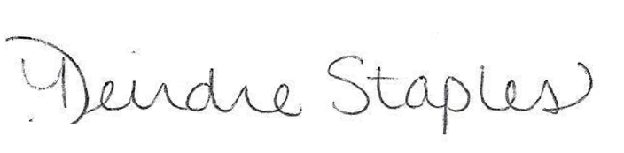

Executive Director of Compliance

